Orange Dot 6.0 - Regional Microdata

Table of Contents

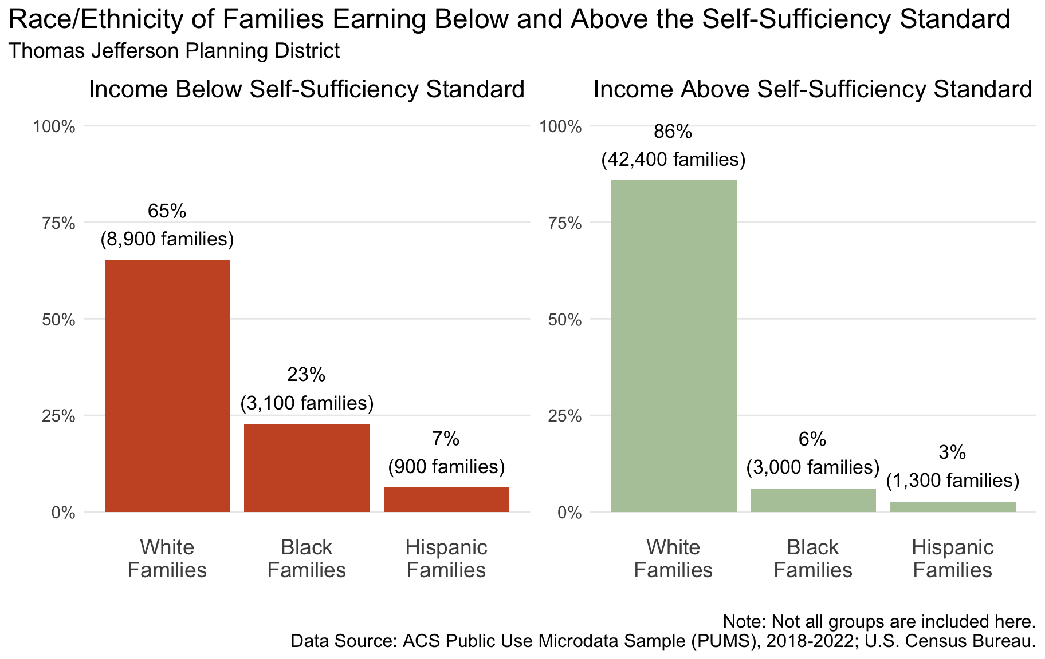

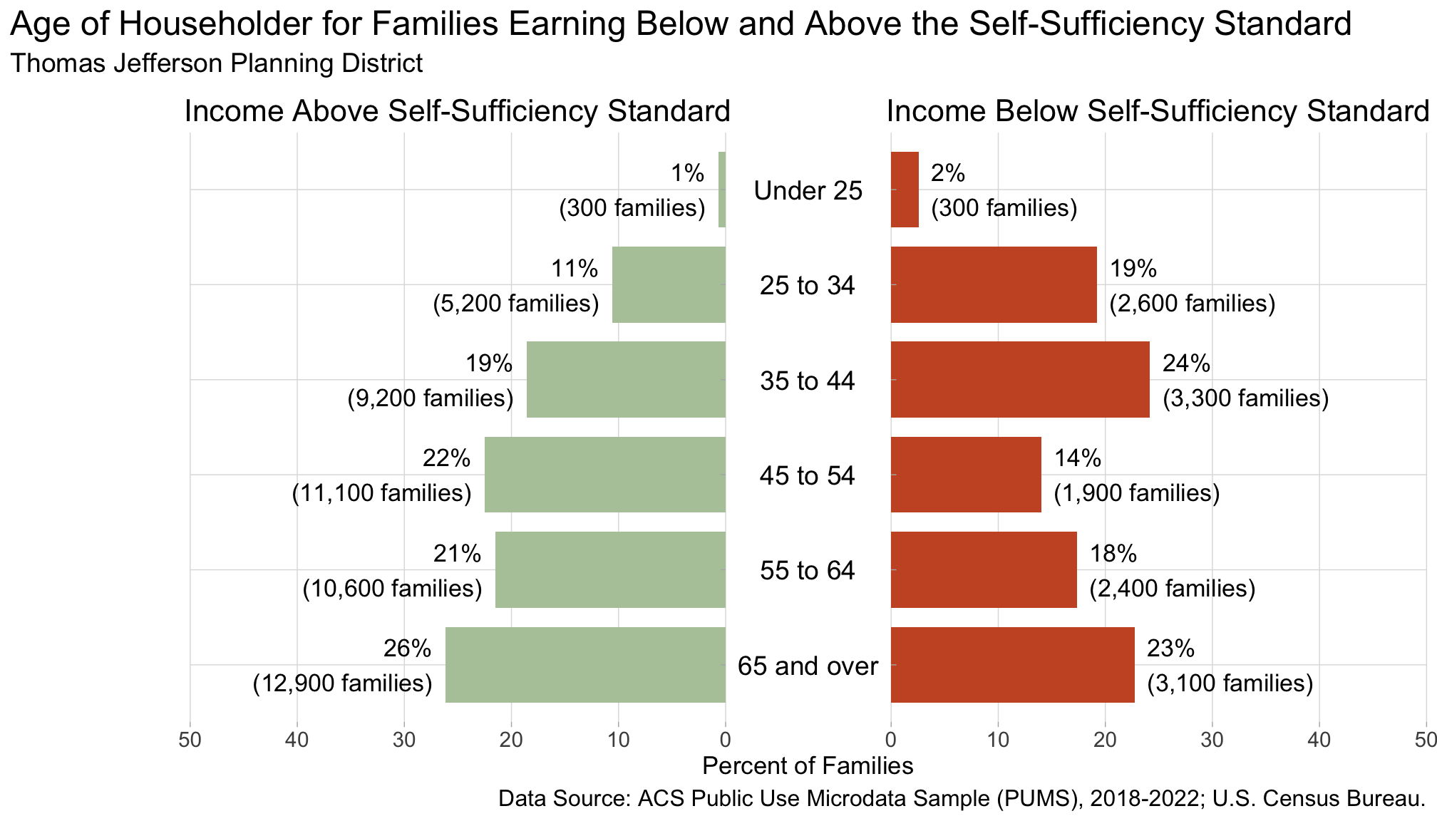

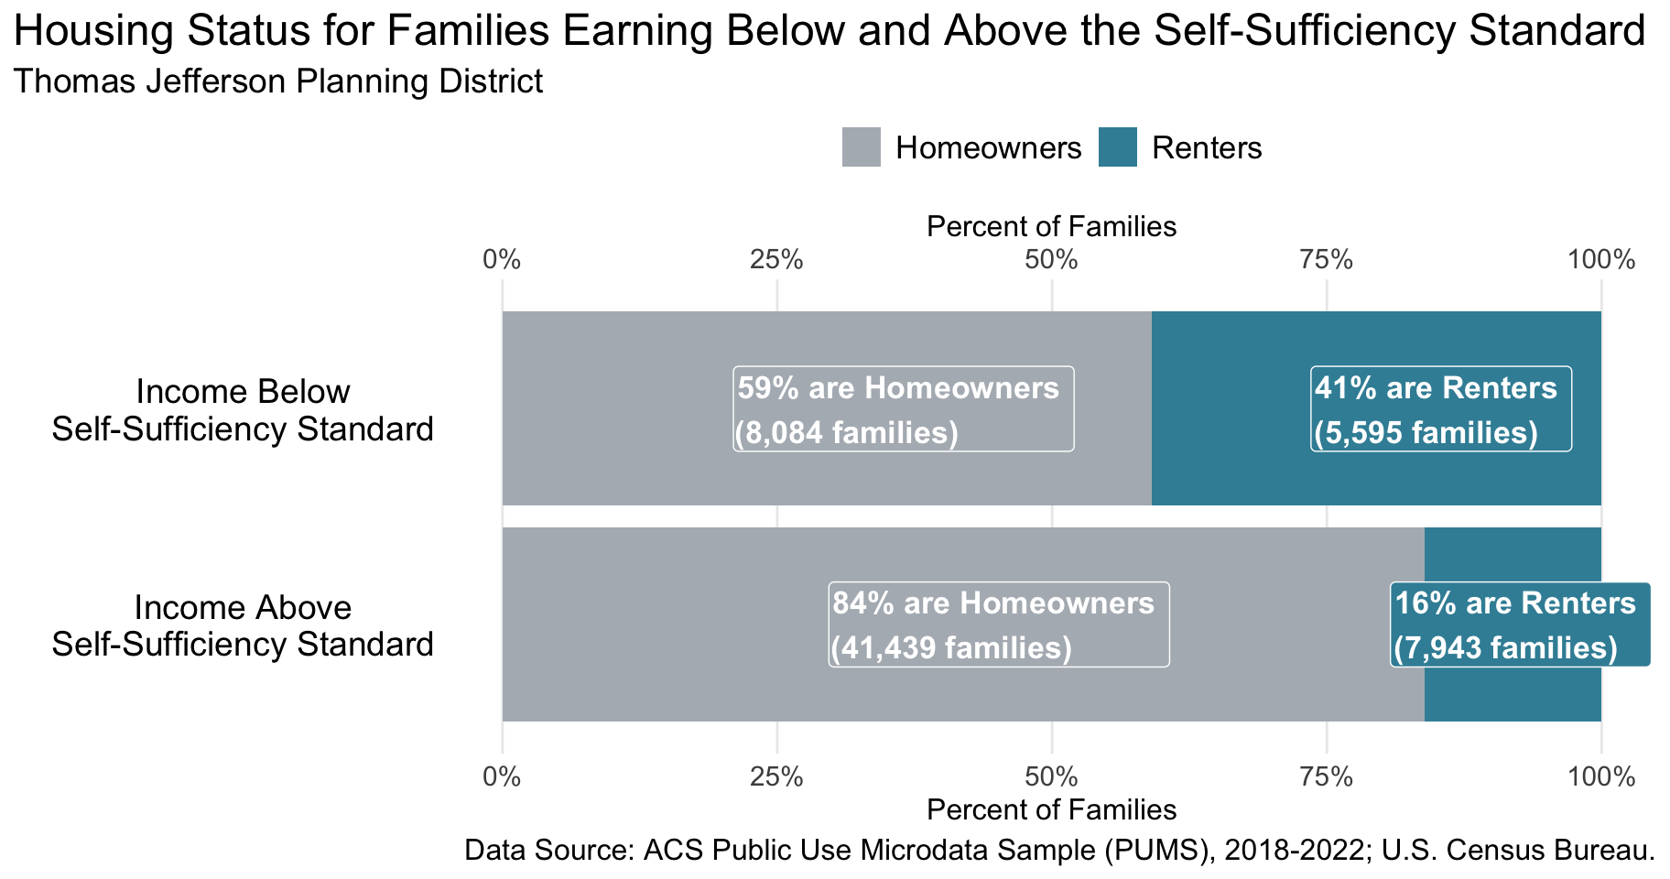

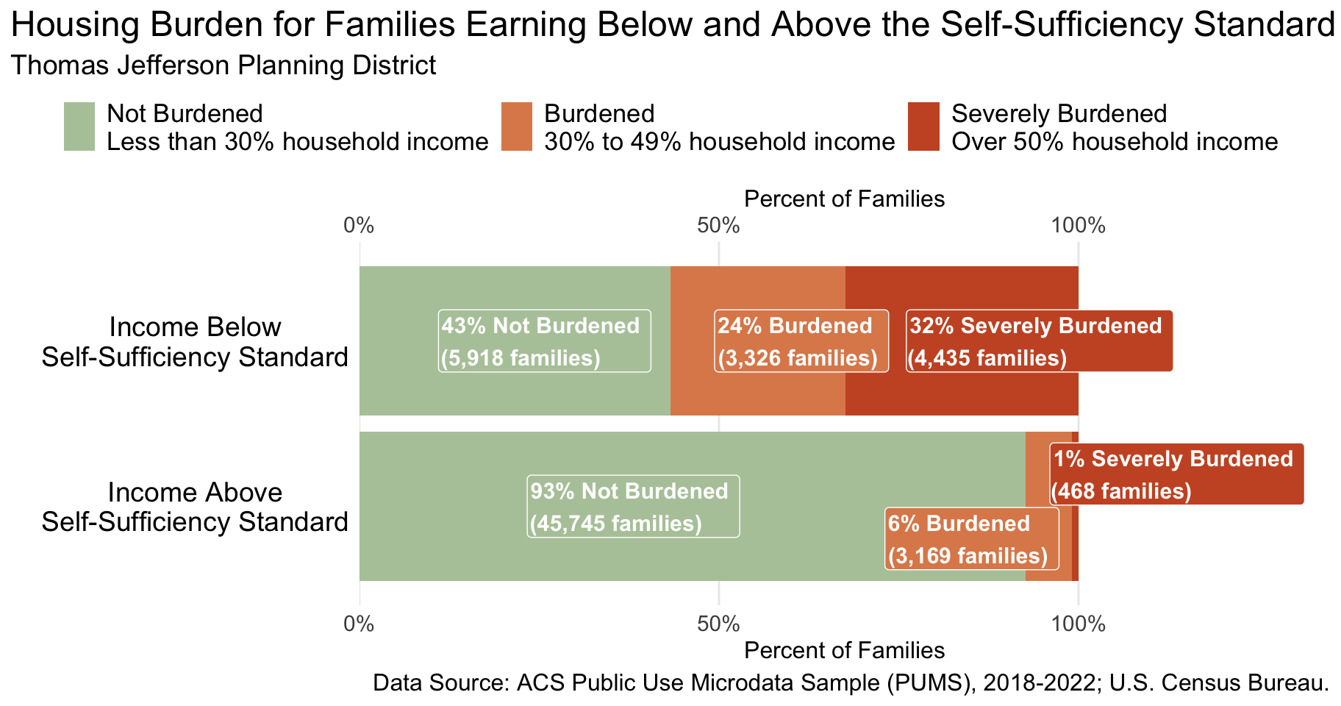

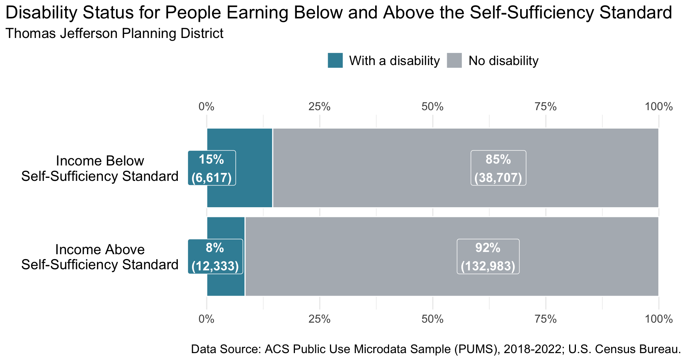

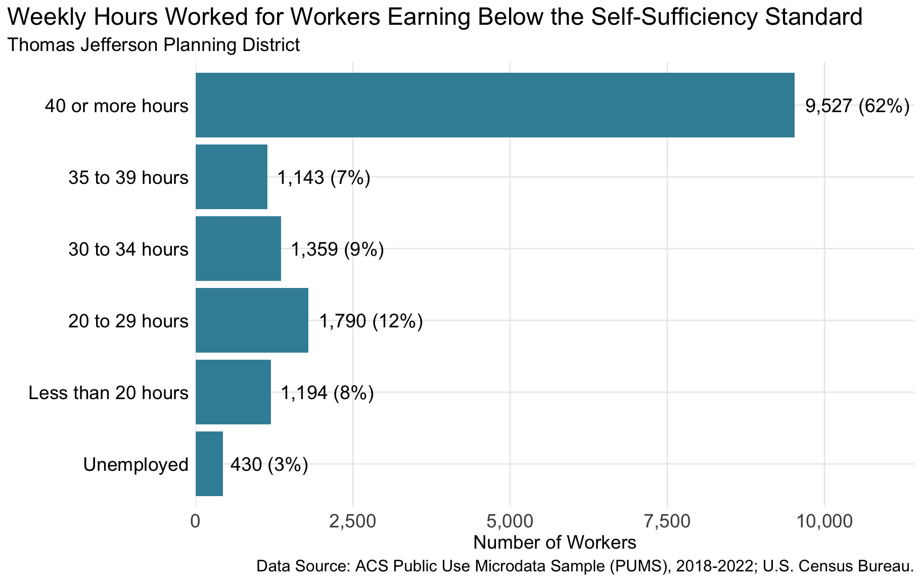

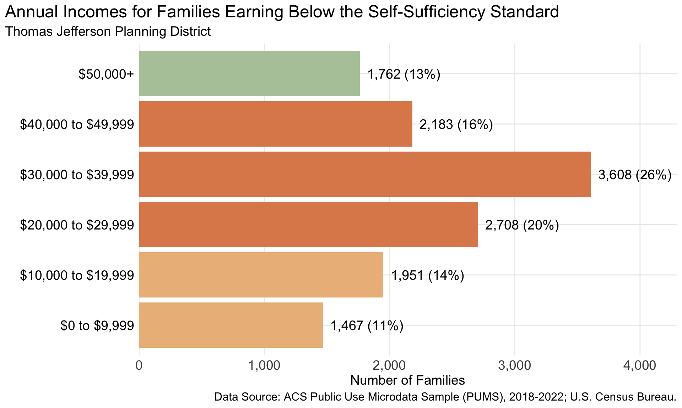

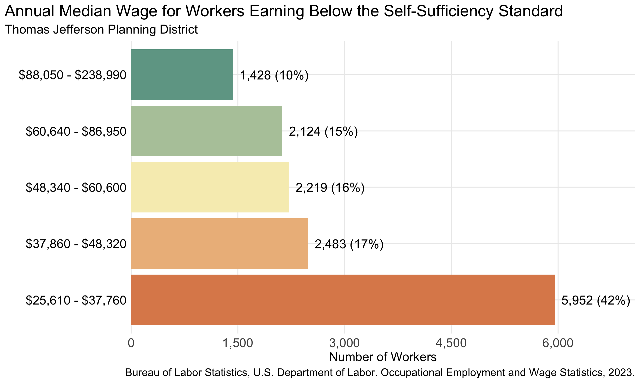

Table 1: Selection of Occupations by Annual Median Wage Earned in the Charlottesville Metro Area*1*

| Occupation | Annual Median Wage |  | Employment Rate*2* | Job Group |
| --- | --- | --- | --- | --- |
| Home Health and Personal Care Aides | $26,720.00 |  | 16% | job group |
| Childcare Workers | $28,390.00 |  | 3% | job group |
| Cashiers | $28,580.00 |  | 21% | job group |
| Fast Food and Counter Workers | $29,190.00 |  | 24% | job group |
| Customer Service Representatives | $36,710.00 |  | 13% | job group |
| Emergency Medical Technicians | $36,940.00 |  | 2% | job group |
| Nursing Assistants | $37,400.00 |  | 15% | job group |
| Healthcare Support Workers, All Other | $37,900.00 |  | 2% | job group |
| Construction Laborers | $38,290.00 |  | 6% | job group |
| Medical Assistants | $39,500.00 |  | 4% | job group |
| Bus Drivers, Transit and Intercity | $41,120.00 |  | 3% | job group |
| Maintenance and Repair Workers, General | $44,210.00 |  | 10% | job group |
| Dental Assistants | $45,640.00 |  | 2% | job group |
| Bus Drivers, School | $47,470.00 |  | 4% | job group |
| Automotive Service Technicians and Mechanics | $48,340.00 |  | 4% | job group |
| Heavy and Tractor-Trailer Truck Drivers | $48,610.00 |  | 6% | job group |
| Carpenters | $48,870.00 |  | 6% | job group |
| Office and Administrative Support Workers, All Other | $48,900.00 |  | 3% | job group |
| Production, Planning, and Expediting Clerks | $50,110.00 |  | 1% | job group |
| Graphic Designers | $51,920.00 |  | 2% | job group |
| Plumbers, Pipefitters, and Steamfitters | $52,090.00 |  | 3% | job group |
| Medical Records Specialists | $54,390.00 |  | 2% | job group |
| Police and Sheriff's Patrol Officers | $56,190.00 |  | 4% | job group |
| Clinical Laboratory Technologists and Technicians | $56,380.00 |  | 2% | job group |
| Heating, Air Conditioning, and Refrigeration Mechanics and Installers | $56,480.00 |  | 3% | job group |
| Electricians | $58,630.00 |  | 7% | job group |
| Elementary School Teachers, Except Special Education | $59,260.00 |  | 9% | job group |
| Secondary School Teachers, Except Special and Career/Technical Education | $60,600.00 |  | 7% | job group |
| Computer User Support Specialists | $60,700.00 |  | 4% | job group |
| Licensed Practical and Licensed Vocational Nurses | $61,120.00 |  | 4% | job group |
| Surgical Technologists | $62,880.00 |  | 1% | job group |
| Electrical and Electronic Engineering Technologists and Technicians | $64,200.00 |  | 1% | job group |
| Radiologic Technologists and Technicians | $74,140.00 |  | 1% | job group |
| Accountants and Auditors | $78,820.00 |  | 10% | job group |
| Registered Nurses | $81,510.00 |  | 28% | job group |
| Dental Hygienists | $92,000.00 |  | 1% | job group |
| Construction Managers | $101,490.00 |  | 2% | job group |
| General and Operations Managers | $105,030.00 |  | 19% | job group |
| Nurse Practitioners | $134,870.00 |  | 4% | job group |
| *1*See appendix for more occupations by annual median wage | | | | |
| *2*Employment rate is the number of jobs (employment) in the given occupation per 1,000 jobs in the Charlottesville Metro Area | | | | |
| Data Source: U.S. Bureau of Labor Statistics, Occupational Employment and Wage Statistics; May 2023 | | | | |

## Appendix

Table 1: Occupations by Annual Median Wage Earned in the Charlottesville Metro Area

| Occupation | Annual Median Wage |  | Employment Rate*1* |
| --- | --- | --- | --- |
| Home Health and Personal Care Aides | $26,720.00 |  | 16% |
| Hosts and Hostesses, Restaurant, Lounge, and Coffee Shop | $27,570.00 |  | 3% |
| Childcare Workers | $28,390.00 |  | 3% |
| Amusement and Recreation Attendants | $28,540.00 |  | 2% |
| Cashiers | $28,580.00 |  | 21% |
| Cooks, Fast Food | $28,840.00 |  | 4% |
| Dining Room and Cafeteria Attendants and Bartender Helpers | $28,900.00 |  | 3% |
| Lifeguards, Ski Patrol, and Other Recreational Protective Service Workers | $29,040.00 |  | 1% |
| Fast Food and Counter Workers | $29,190.00 |  | 24% |
| Food Preparation Workers | $29,260.00 |  | 5% |
| Dishwashers | $29,330.00 |  | 4% |
| Food Servers, Nonrestaurant | $29,370.00 |  | 2% |
| Bakers | $29,370.00 |  | 1% |
| Animal Caretakers | $29,680.00 |  | 3% |
| Laundry and Dry-Cleaning Workers | $29,790.00 |  | 1% |
| Retail Salespersons | $29,940.00 |  | 22% |
| Hotel, Motel, and Resort Desk Clerks | $30,010.00 |  | 3% |
| Janitors and Cleaners, Except Maids and Housekeeping Cleaners | $30,180.00 |  | 9% |
| Cleaners of Vehicles and Equipment | $30,690.00 |  | 1% |
| Demonstrators and Product Promoters | $30,740.00 |  | 1% |
| Packers and Packagers, Hand | $30,770.00 |  | 1% |
| Shuttle Drivers and Chauffeurs | $31,990.00 |  | 2% |
| Parts Salespersons | $32,040.00 |  | 1% |
| Maids and Housekeeping Cleaners | $32,770.00 |  | 12% |
| Waiters and Waitresses | $33,060.00 |  | 18% |
| Farmworkers and Laborers, Crop, Nursery, and Greenhouse | $33,250.00 |  | 1% |
| Recreation Workers | $33,590.00 |  | 2% |
| Stockers and Order Fillers | $33,740.00 |  | 14% |
| Veterinary Assistants and Laboratory Animal Caretakers | $33,890.00 |  | 2% |
| Receptionists and Information Clerks | $34,160.00 |  | 7% |
| Substitute Teachers, Short-Term | $34,640.00 |  | 5% |
| Cooks, Restaurant | $34,950.00 |  | 11% |
| Teaching Assistants, Except Postsecondary | $35,250.00 |  | 9% |
| Laborers and Freight, Stock, and Material Movers, Hand | $35,460.00 |  | 7% |
| Cooks, Institution and Cafeteria | $36,210.00 |  | 4% |
| Miscellaneous Assemblers and Fabricators | $36,480.00 |  | 2% |
| Landscaping and Groundskeeping Workers | $36,700.00 |  | 8% |
| Customer Service Representatives | $36,710.00 |  | 13% |
| Emergency Medical Technicians | $36,940.00 |  | 2% |
| Merchandise Displayers and Window Trimmers | $37,010.00 |  | 1% |
| Hairdressers, Hairstylists, and Cosmetologists | $37,130.00 |  | 2% |
| Counter and Rental Clerks | $37,270.00 |  | 3% |
| Nursing Assistants | $37,400.00 |  | 15% |
| Preschool Teachers, Except Special Education | $37,610.00 |  | 2% |
| Shipping, Receiving, and Inventory Clerks | $37,760.00 |  | 3% |
| Healthcare Support Workers, All Other | $37,900.00 |  | 2% |
| Security Guards | $37,920.00 |  | 3% |
| Driver/Sales Workers | $38,000.00 |  | 3% |
| Medical Secretaries and Administrative Assistants | $38,200.00 |  | 5% |
| Industrial Truck and Tractor Operators | $38,270.00 |  | 1% |
| Construction Laborers | $38,290.00 |  | 6% |
| Electrical, electronic, and electromechanical assemblers, except coil winders, tapers, and finishers | $38,290.00 |  | 2% |
| Tellers | $38,410.00 |  | 1% |
| Firefighters | $38,990.00 |  | 3% |
| Medical Assistants | $39,500.00 |  | 4% |
| Social and Human Service Assistants | $39,680.00 |  | 3% |
| Office Clerks, General | $39,990.00 |  | 18% |
| Bus Drivers, Transit and Intercity | $41,120.00 |  | 3% |
| Light Truck Drivers | $41,390.00 |  | 4% |
| Bartenders | $42,640.00 |  | 5% |
| Maintenance and Repair Workers, General | $44,210.00 |  | 10% |
| Highway Maintenance Workers | $44,280.00 |  | 1% |
| Pharmacy Technicians | $44,480.00 |  | 4% |
| First-Line Supervisors of Food Preparation and Serving Workers | $44,630.00 |  | 9% |
| Painters, Construction and Maintenance | $44,810.00 |  | 1% |
| Library Technicians | $44,870.00 |  | 1% |
| Billing and Posting Clerks | $45,050.00 |  | 1% |
| Separating, Filtering, Clarifying, Precipitating, and Still Machine Setters, Operators, and Tenders | $45,160.00 |  | 1% |
| Insurance Claims and Policy Processing Clerks | $45,490.00 |  | 1% |
| Dental Assistants | $45,640.00 |  | 2% |
| First-Line Supervisors of Housekeeping and Janitorial Workers | $45,970.00 |  | 2% |
| First-Line Supervisors of Personal Service Workers | $46,200.00 |  | 1% |
| Self-Enrichment Teachers | $46,760.00 |  | 2% |
| Exercise Trainers and Group Fitness Instructors | $46,810.00 |  | 4% |
| Correctional Officers and Jailers | $46,840.00 |  | 5% |
| Operating Engineers and Other Construction Equipment Operators | $46,970.00 |  | 3% |
| Bus Drivers, School | $47,470.00 |  | 4% |
| Bookkeeping, Accounting, and Auditing Clerks | $47,610.00 |  | 10% |
| Secretaries and Administrative Assistants, Except Legal, Medical, and Executive | $47,620.00 |  | 12% |
| First-Line Supervisors of Retail Sales Workers | $47,710.00 |  | 8% |
| Coaches and Scouts | $47,830.00 |  | 2% |
| Real Estate Sales Agents | $47,840.00 |  | 2% |
| Automotive Service Technicians and Mechanics | $48,340.00 |  | 4% |
| Heavy and Tractor-Trailer Truck Drivers | $48,610.00 |  | 6% |
| Inspectors, Testers, Sorters, Samplers, and Weighers | $48,670.00 |  | 1% |
| Cement Masons and Concrete Finishers | $48,680.00 |  | 2% |
| Carpenters | $48,870.00 |  | 6% |
| Office and Administrative Support Workers, All Other | $48,900.00 |  | 3% |
| Substance abuse, behavioral disorder, and mental health counselors | $49,820.00 |  | 2% |
| Production, Planning, and Expediting Clerks | $50,110.00 |  | 1% |
| Detectives and Criminal Investigators | $50,210.00 |  | 1% |
| Bus and Truck Mechanics and Diesel Engine Specialists | $51,420.00 |  | 1% |
| Biological Technicians | $51,750.00 |  | 2% |
| Graphic Designers | $51,920.00 |  | 2% |
| Chefs and Head Cooks | $52,000.00 |  | 2% |
| Securities, Commodities, and Financial Services Sales Agents | $52,070.00 |  | 3% |
| Plumbers, Pipefitters, and Steamfitters | $52,090.00 |  | 2% |
| First-Line Supervisors of Transportation Workers, Except Aircraft Cargo Handling Supervisors | $53,740.00 |  | 2% |
| Child, Family, and School Social Workers | $53,890.00 |  | 2% |
| Medical Records Specialists | $54,390.00 |  | 2% |
| Police and Sheriff's Patrol Officers | $56,190.00 |  | 4% |
| Kindergarten Teachers, Except Special Education | $56,310.00 |  | 1% |
| Clinical Laboratory Technologists and Technicians | $56,380.00 |  | 2% |
| First-Line Supervisors of Landscaping, Lawn Service, and Groundskeeping Workers | $56,380.00 |  | 1% |
| Heating, Air Conditioning, and Refrigeration Mechanics and Installers | $56,480.00 |  | 3% |
| Special Education Teachers, Secondary School | $56,580.00 |  | 2% |
| Insurance Sales Agents | $56,590.00 |  | 3% |
| First-Line Supervisors of Correctional Officers | $56,760.00 |  | 2% |
| Postal Service Mail Carriers | $56,760.00 |  | 2% |
| Electricians | $58,630.00 |  | 7% |
| Elementary School Teachers, Except Special Education | $59,260.00 |  | 9% |
| Paralegals and Legal Assistants | $59,660.00 |  | 2% |
| First-Line Supervisors of Office and Administrative Support Workers | $59,990.00 |  | 9% |
| Sales Representatives of Services, Except Advertising, Insurance, Financial Services, and Travel | $60,010.00 |  | 7% |
| Educational, Guidance, and Career Counselors and Advisors | $60,320.00 |  | 4% |
| Sales Representatives, Wholesale and Manufacturing, Except Technical and Scientific Products | $60,390.00 |  | 4% |
| Secondary School Teachers, Except Special and Career/Technical Education | $60,600.00 |  | 7% |
| Computer User Support Specialists | $60,700.00 |  | 4% |
| Meeting, Convention, and Event Planners | $60,780.00 |  | 2% |
| Special Education Teachers, Kindergarten and Elementary School | $60,950.00 |  | 2% |
| Licensed Practical and Licensed Vocational Nurses | $61,120.00 |  | 4% |
| Healthcare Social Workers | $61,230.00 |  | 1% |
| Fundraisers | $61,940.00 |  | 2% |
| Medical Scientists, Except Epidemiologists | $61,940.00 |  | 6% |
| Editors | $62,250.00 |  | 2% |
| Middle School Teachers, Except Special and Career/Technical Education | $62,290.00 |  | 5% |
| Food Service Managers | $62,750.00 |  | 1% |
| Surgical Technologists | $62,880.00 |  | 1% |
| Business Operations Specialists, All Other | $63,250.00 |  | 7% |
| Property, Real Estate, and Community Association Managers | $63,320.00 |  | 1% |
| Electrical and Electronic Engineering Technologists and Technicians | $64,200.00 |  | 1% |
| Executive Secretaries and Executive Administrative Assistants | $64,280.00 |  | 3% |
| Compliance Officers | $65,320.00 |  | 2% |
| Cost Estimators | $65,500.00 |  | 1% |
| First-Line Supervisors of Mechanics, Installers, and Repairers | $65,680.00 |  | 3% |
| Training and Development Specialists | $67,810.00 |  | 3% |
| Market Research Analysts and Marketing Specialists | $67,940.00 |  | 6% |
| Compensation, Benefits, and Job Analysis Specialists | $67,990.00 |  | 1% |
| First-Line Supervisors of Production and Operating Workers | $68,380.00 |  | 2% |
| Loan Officers | $72,050.00 |  | 1% |
| Human Resources Specialists | $72,990.00 |  | 6% |
| Librarians and Media Collections Specialists | $73,330.00 |  | 2% |
| Radiologic Technologists and Technicians | $74,140.00 |  | 1% |
| First-Line Supervisors of Construction Trades and Extraction Workers | $74,270.00 |  | 7% |
| Buyers and Purchasing Agents | $74,480.00 |  | 3% |
| Accountants and Auditors | $78,820.00 |  | 10% |
| Financial Specialists, All Other | $79,000.00 |  | 1% |
| Respiratory Therapists | $80,550.00 |  | 1% |
| First-Line Supervisors of Non-Retail Sales Workers | $80,610.00 |  | 2% |
| Instructional Coordinators | $81,130.00 |  | 2% |
| Registered Nurses | $81,510.00 |  | 28% |
| Management Analysts | $82,990.00 |  | 6% |
| Civil Engineers | $85,570.00 |  | 2% |
| Web Developers | $88,120.00 |  | 1% |
| Architects, Except Landscape and Naval | $89,590.00 |  | 1% |
| Mechanical Engineers | $89,600.00 |  | 1% |
| Personal Financial Advisors | $91,880.00 |  | 2% |
| Dental Hygienists | $92,000.00 |  | 1% |
| Project Management Specialists | $93,110.00 |  | 7% |
| Software Quality Assurance Analysts and Testers | $93,820.00 |  | 2% |
| Network and Computer Systems Administrators | $95,650.00 |  | 3% |
| Occupational Therapists | $96,380.00 |  | 1% |
| Physical Therapists | $99,820.00 |  | 2% |
| Financial and Investment Analysts | $99,860.00 |  | 2% |
| Electrical Engineers | $99,890.00 |  | 1% |
| Education Administrators, Kindergarten through Secondary | $100,280.00 |  | 2% |
| Computer Systems Analysts | $101,130.00 |  | 4% |
| Construction Managers | $101,490.00 |  | 2% |
| Administrative Services Managers | $101,810.00 |  | 2% |
| General and Operations Managers | $105,030.00 |  | 19% |
| English Language and Literature Teachers, Postsecondary | $108,000.00 |  | 2% |
| Information Security Analysts | $109,480.00 |  | 2% |
| Computer Occupations, All Other | $111,610.00 |  | 1% |
| Social Scientists and Related Workers, All Other | $114,900.00 |  | 3% |
| Data Scientists | $117,410.00 |  | 1% |
| Software Developers | $120,310.00 |  | 13% |
| Medical and Health Services Managers | $124,910.00 |  | 3% |
| Biological Science Teachers, Postsecondary | $130,650.00 |  | 1% |
| Sales Managers | $131,380.00 |  | 2% |
| Public Relations Managers | $132,410.00 |  | 1% |
| Managers, All Other | $133,300.00 |  | 4% |
| Nurse Practitioners | $134,870.00 |  | 4% |
| Pharmacists | $136,340.00 |  | 3% |
| Human Resources Managers | $137,610.00 |  | 1% |
| Lawyers | $140,360.00 |  | 3% |
| Financial Managers | $152,780.00 |  | 4% |
| Marketing Managers | $155,010.00 |  | 2% |
| Computer and Information Systems Managers | $155,320.00 |  | 4% |
| Physicians, All Other | $206,860.00 |  | 9% |
| Chief Executives | $238,990.00 |  | 1% |
| *1*Employment rate per 1,000 jobs in the Charlottesville Metro Area | | | |
| Data Source: U.S. Bureau of Labor Statistics, Occupational Employment and Wage Statistics; May 2023 | | | |

